Scanning a Newspaper Advertisement
Have a quick look through the advert below, then answer the questions.
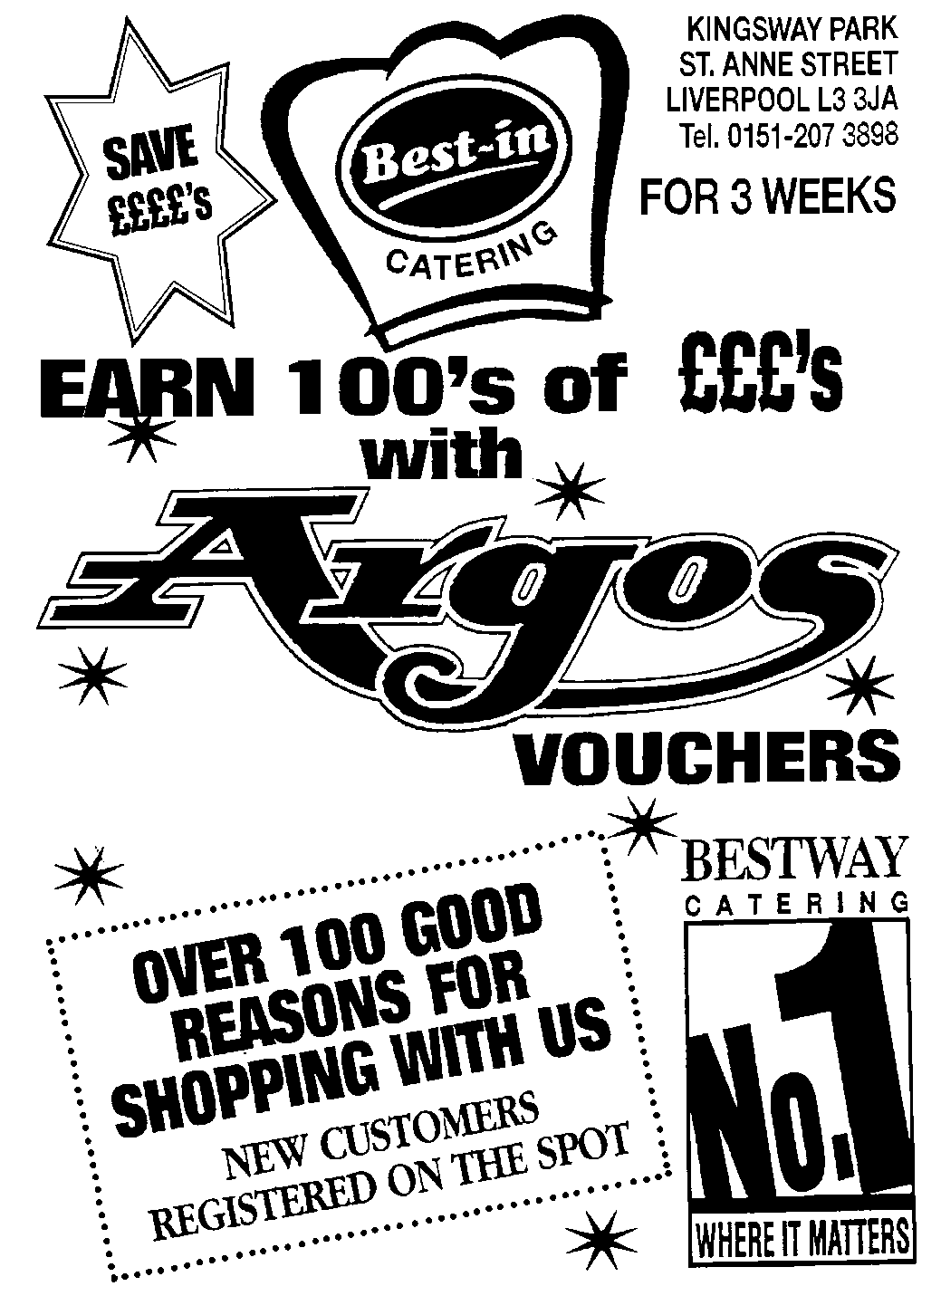
Questions

1 What can you save from shopping at this place?

2 How many good reasons are there for shopping there?

3 What is the telephone number?

4 What can you earn with Argos?

5 What are the names of the catering firm?

6 How long does the offer last?

