**Sample Exercise 5.**

*Directions:* Choose a book. You will have five minutes to preview the book. Use the checklist below to find out all you can about the book. Then tell another student about the book.

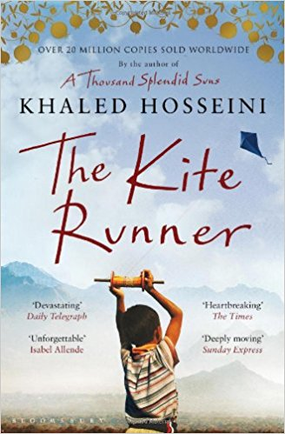

*source:* <https://images-na.ssl-images-amazon.com/images/I/51M3Kl80Z%2BL._SX326_BO1,204,203,200_.jpg>

*Checklist of key features:*

|  |  |
| --- | --- |
| ___ | Title______________________________________________________________________________ |
| ___ | Author____________________________________________________________________________ |
| ___ | Type of the book |
|  | fiction_______________________________ non-fiction _______________________________ |
| ___ | What’s it about?___________________________________________________________________ |
| ___ | Date of publication _________________________________________________________________ |
| ___ | Length of book _________________________________________________________ pages |
| ___ | Print easy to read _______________________________ yes ______________ no _______________ |
| ___ | Front and back cover materials_____________________yes ______________ no _______________ |

*Directions:* Did all books have all of these features? Would you like to read this book? Why?

(During the class discussion of the books and their features, it is a good idea to make sure that students understand the meaning and the significance of all the features. They may not realize, for example, that very small print will make their eyes tired and discourage them from reading.)